Table of Contents

Introduction 2

Objectives 2

Data Source 2

Data Set 2

Exploratory Data Analysis 3

Stratified Sampling of Data 3

Data Preprocessing 3

Graphical Results 3

Methodology 6

Algorithm Performance Comparison 6

Variable Importance 7

Model Correlation 8

Model Improvement with Stacked and Ensemble Models 8

Cost Analysis 9

Conclusion and Recommendation 9

Appendix 10

R Code with sample output 10

# Introduction

A Taiwanese Banking Institution has provided data related to the credit card payments of their customers. The data highlights customers’ credit card bill amount and their payment history over the last six months. In this project, I have built and compared classification models which predicts the clients who are more likely to default the next month’s credit card payment.

For this project, I have also conducted the cost analysis for the bank. The bank would also like to contact the customers who are likely to default through a phone call. If the bank does not make the call, the bank is assumed to lose a certain amount of money, this means there is a cost associated with bank not being able to identify the customers who are likely to default.

# Objectives

* Build a classification model to predict whether the client will default the credit card payment next month or not
* To identify a model that minimizes the cost to the bank which includes the cost of making a call as well as cost of not being able to identify the customers who are likely to default

# Data Source

The data is available on UCI Machine Learning repository (https://archive.ics.uci.edu/). The data set contains 30000 instances and 24 attributes. The outcome is whether the customer will or will not default the next month’s credit card payment. 22% of the 30000 customers defaulted the next month’s payment in the dataset.

# Data Set

This output or response variable is a binary variable that depicts default payment (Yes = 1, No = 0), as the response variable. There are 23 independent variables which are used to predict the default of payment and are explained as below:

|  |  |  |
| --- | --- | --- |
| **Variable** | **Variable Name** | **Description** |
| X1 | LIMIT_BAL | Amount of the given credit (NT dollar): it includes both the individual consumer credit and his/her family (supplementary) credit |
| X2 | SEX | Gender (1 = male; 2 = female) |
| X3 | EDUCATION | Education (1 = graduate school; 2 = university; 3 = high school; 4 = others) |
| X4 | MARRIAGE | Marital status (1 = married; 2 = single; 3 = others) |
| X5 | AGE | Age (year) |
| X6 | PAY_1 | The repayment status in September, 2005 |
| X7 | PAY_2 | The repayment status in August, 2005 |
| X8 | PAY_3 | The repayment status in July, 2005 |
| X9 | PAY_4 | The repayment status in June, 2005 |
| X10 | PAY_5 | The repayment status in May, 2005 |
| X11 | PAY_6 | The repayment status in April, 2005 |
| X12 | BILL_AMT1 | Amount of bill statement in September, 2005 |
| X13 | BILL_AMT2 | Amount of bill statement in August, 2005 |
| X14 | BILL_AMT3 | Amount of bill statement in July, 2005 |
| X15 | BILL_AMT4 | Amount of bill statement in June, 2005 |
| X16 | BILL_AMT5 | Amount of bill statement in May, 2005 |
| X17 | BILL_AMT6 | Amount of bill statement in Apil, 2005 |
| X18 | PAY_AMT1 | Amount paid in September, 2005 |
| X19 | PAY_AMT2 | Amount paid in August, 2005 |
| X20 | PAY_AMT3 | Amount paid in July, 2005 |
| X21 | PAY_AMT4 | Amount paid in June, 2005 |
| X22 | PAY_AMT5 | Amount paid in May, 2005 |
| X23 | PAY_AMT6 | Amount paid in April, 2005 |
| Y | default payment next month | Payment default (Yes = 1, No = 0) |

Note: Measurement scale for the repayment status is: -1 = pay duly; 1 = payment delay for one month; 2 = payment delay for two months; 3 = payment delay for three months; 8 = payment delay for eight months; 9 = payment delay for nine months and above.

# Exploratory Data Analysis

## Stratified Sampling of Data

The dataset has 30000 instances; therefore, I performed a stratified sampling of the data to take a subset of data to perform classification. I took 15% of the data which resulted in a selection of 4500 instances.

This data was further divided into training and test data. 67% or 2/3 of the data was used to train the classifier and 33% or 1/3 of the data was used to test the performance of the classifiers used.

## Data Preprocessing

There was no missing data and hence no data cleaning was required. However, some preprocessing was conducted to make the data readable and ready for classification:

* The data type for all the variables was numeric, the nominal variables were identified and converted into factor variables.
* The output column was renamed as ‘class’ for ease of reference
* The class column was recoded as ‘yes’ for values ‘1’ and ‘no’ for values ‘0’
* The class column was releveled to make sure the positive class is always considered as ‘yes’
* The ID column was dropped since it had unique values

## Graphical Results

Some basic visualization was performed on the dataset like missing values, class and gender distribution, and amount of given credit.

Missing Values

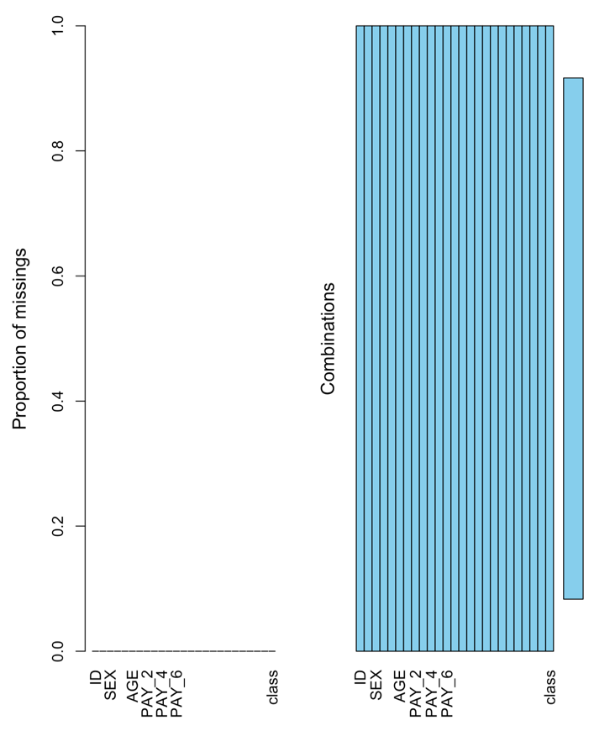

Class distribution

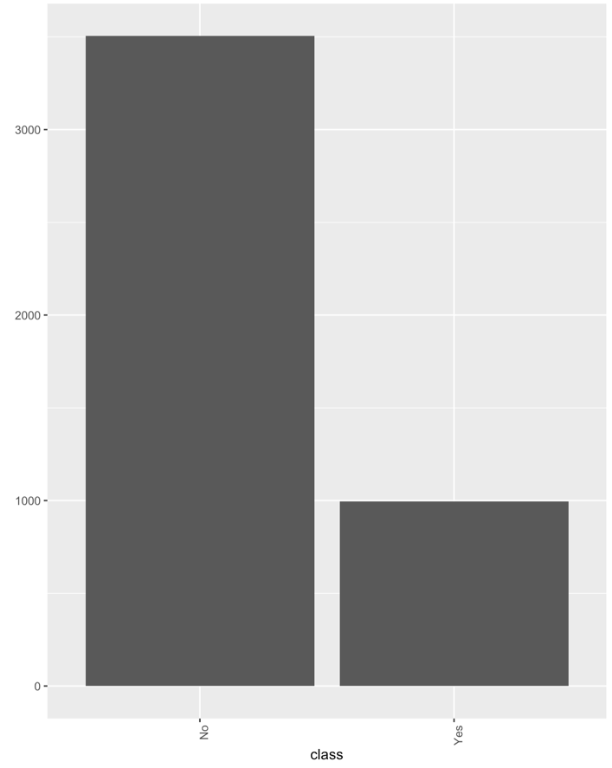

Gender distribution

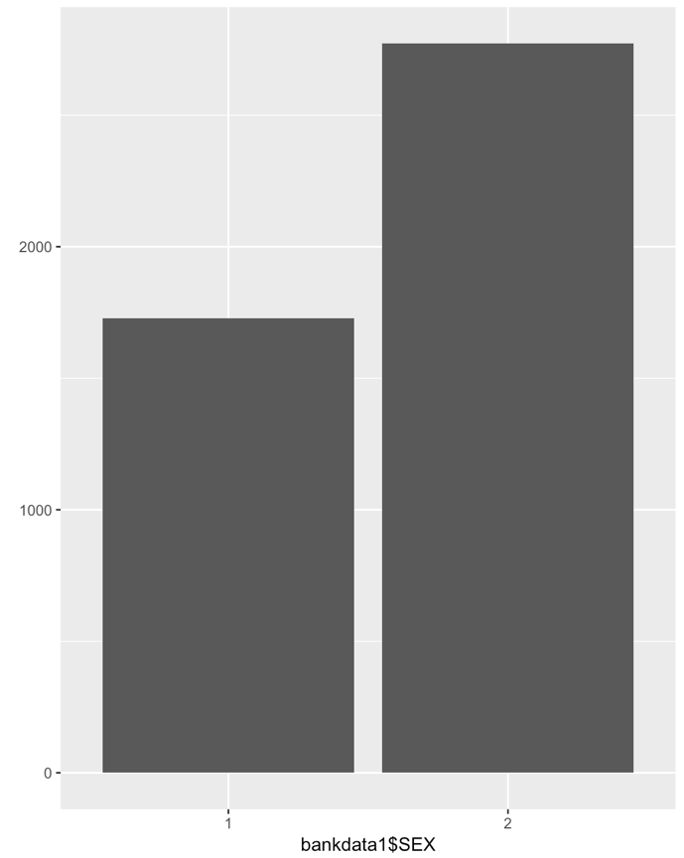

Amount of given credit

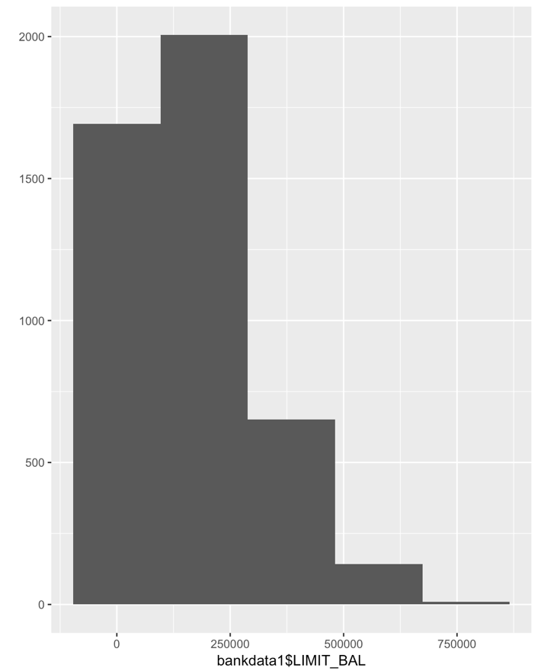

Amount of given credit in the respective classes

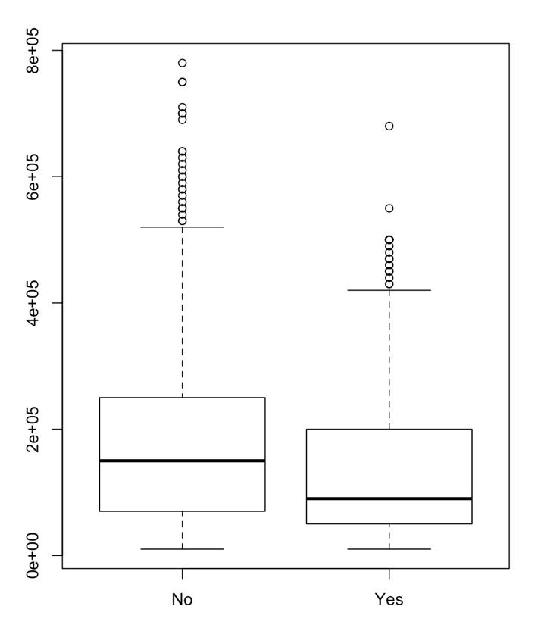

# Methodology

The task at hand was a binary classification problem with two possible responses or classes – Yes and No. I used 4 individual classifiers for prediction at first and then built stacked and ensemble models using all 4 classifiers and two of the least correlated of them.

* **Nonlinear algorithms**: Decision Tree (C5.0) and Naïve Bayes (NB)
* **Bagging algorithms**: Random Forest (RF)
* **Boosting algorithms**: Gradient Boosting (GBM)

## Algorithm Performance Comparison

The 4x4 Matrix (Models vs Metrics) below lists the performance of each classifier:

|  |  |  |  |  |  |
| --- | --- | --- | --- | --- | --- |
| **Model** | **Accuracy** | **Sensitivity** | **Specificity** | **Precision** | **F1 Score** |
| **Decision Tree** | 0.8113 | 0.3293 | 0.9481 | 0.6429 | 0.4355 |
| **Naïve Bayes** | 0.6813 | 0.6768 | 0.6825 | 0.3768 | 0.4842 |
| **Random Forest** | 0.7999 | 0.4207 | 0.9074 | 0.5633 | 0.4817 |
| **GBM** | 0.7776 | 0.5762 | 0.8348 | 0.4974 | 0.5339 |

Since it is an imbalanced dataset, accuracy alone cannot be a good measure of classifier performance, we need precision and/or recall too to identify the best performing classifier. The imbalance of dataset also means that the models are better at predicting ‘no’ class (customers who do not default a payment) as compared to the ‘yes’ class. This is due to the fact that there are more customers who didn’t default in the dataset and we took a stratified sample for predicting to represent the dataset correctly.

And since our goal here is to predict whether the customer will default or not, recall / sensitivity holds more importance for us. The bank would like to correctly identify the customers who are likely to default. Here, our positive class is ‘yes’ and since Recall is TP/P, we need high recall to be able to correctly identify all true positive class customers. Decision Tree gives us the best accuracy and precision but lowest recall. Naïve Bayes gives us least accuracy and precision but maximum recall. Random Forest and GBM give us a balanced mix of Accuracy, Sensitivity and Precision.

I performed a weighted F-measure comparison with Beta > 1 to further compare the performance of the classifiers. GBM has the maximum weighted F measure with Beta = 1.1 and hence is the recommended model.

|  |  |
| --- | --- |
| **Model** | **F score at Beta = 1.1** |
| **Decision Tree** | 0.4225 |
| **Naïve Bayes** | 0.4976 |
| **Random Forest** | 0.4751 |
| **GBM** | 0.5377 |

## Variable Importance

Variable importance for all 4 models developed was also studied and the variable PAY_1 i.e. the repayment status in September 2005 was pegged as one of the most important among all the classifiers. This means that the customers who missed the last payment are most likely to default the next credit card payment. Therefore, it is suggested to the bank that more emphasis should be put on these customers and they should be identified and contacted to urge for meeting the payment deadline.

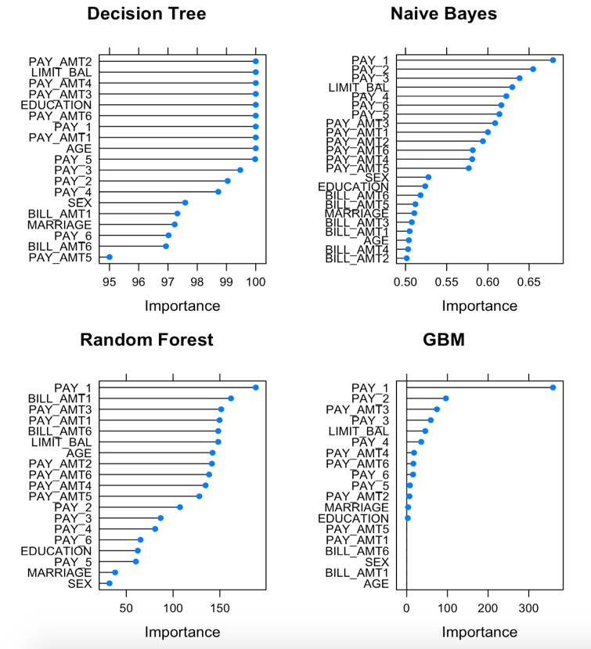

## Model Correlation

Then I studied the correlation for 4 models developed earlier to find out the least correlated models.

4x4 Model Prediction Correlation Matrix and plots:

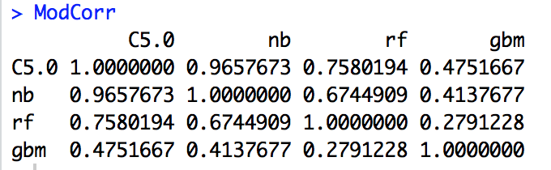

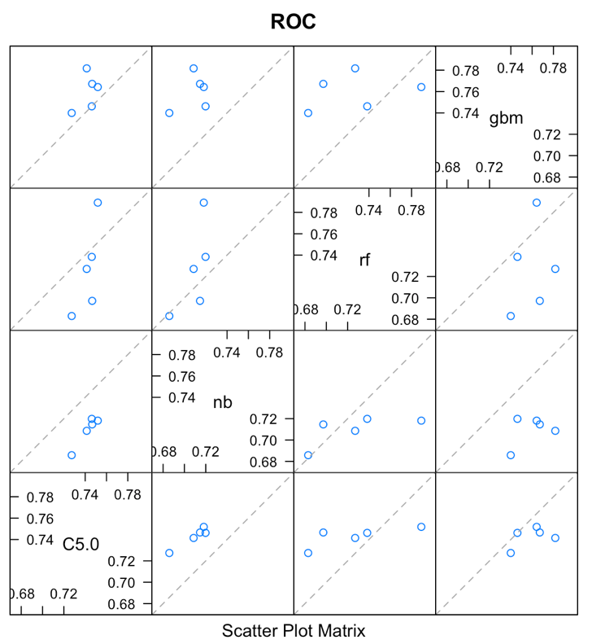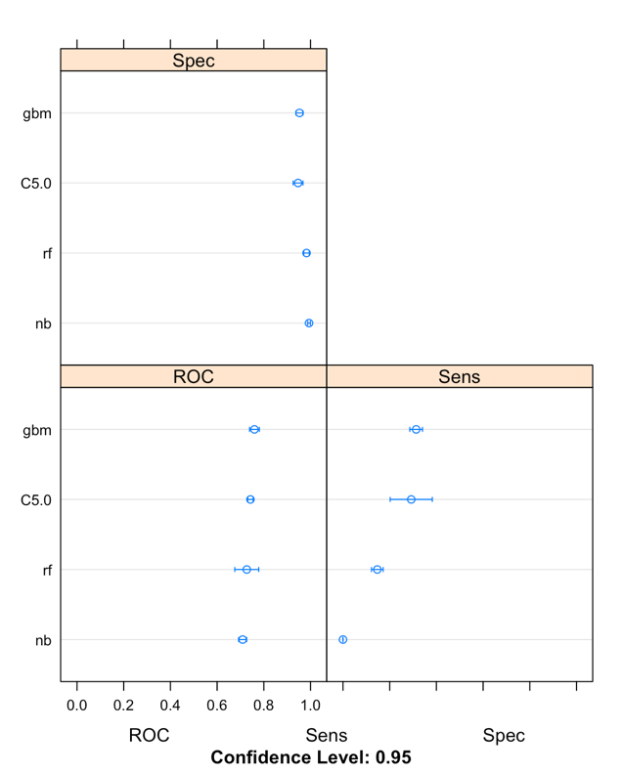

## Model Improvement with Stacked and Ensemble Models

The models were further improved by building stacked and ensemble models using all the 4 models developed earlier and the two least correlated models identified above through model correlation. The two least correlated models were used so that if one model does not work the other would give the desired results.

6 models in total were built with sensitivity as the optimization metric and tested with the following results:

|  |  |  |  |  |
| --- | --- | --- | --- | --- |
| **Model** | **Accuracy** | **Sensitivity** | **Precision** | **F1 Score** |
| **Stack – all 4 models** | 0.8261 | 0.4390 | 0.6606 | 0.5275 |
| **Stack – 2 least correlated models** | 0.8187 | 0.4543 | 0.6234 | 0.5256 |
| **Stack – all 4 models + up sampling** | 0.7983 | 0.5274 | 0.5340 | 0.5307 |
| **Ensemble – all 4 models** | 0.8255 | 0.3476 | 0.7169 | 0.4682 |
| **Ensemble – 2 least correlated models** | 0.8248 | 0.3415 | 0.7179 | 0.4628 |
| **Ensemble – all 4 models + up sampling** | 0.7803 | 0.5549 | 0.5028 | 0.5275 |

Ensemble model built with all 4 classifiers and up sampling resulted in the maximum recall but least accuracy and precision. The stacked model built using all 4 models and up sampling gave slightly less recall but performed better on accuracy and precision. It also has the highest F1 score.

Therefore, up sampling for both stacked and ensemble models has resulted in the best numbers, but it is still not as good as GBM in terms of Recall (0.5762) and F1 Score (0.5339).

## Cost Analysis

For this project, I have assumed that after predicting the customers who are likely to default the next month’s payment, the bank would like to take some action. Let’s say the bank calls every customer who is expected to default. When a person who is not likely to default but is contacted (FP / False Positive) the bank incurs a cost of $1. And for every person who is expected to default but is not contacted (FN / False Negative), the bank incurs a cost of $10.

Three models were built and tested to minimize the cost to the bank. The models were developed using Decision Tree, Naïve Bayes and Random Forest algorithms and the profit calculated for each is as follows. The Naïve Bayes method results in the minimum cost and maximum profits.

|  |  |  |
| --- | --- | --- |
| **Model** | **Cost in $** | **Profit in $** |
| **Decision Tree** | 1563 | 1527 |
| **Naïve Bayes** | 1260 | 1738 |
| **Random Forest** | 2227 | 942 |

# Conclusion and Recommendation

This project was focused on building a model to predict whether a customer will default the next month credit card payment and identify the model that minimizes the cost for the bank.

I performed required data preprocessing including stratified sampling and datatype conversion. Then I developed a mix of non-linear, bagging, and boosting algorithms and assessed them using accuracy, recall, precision and weighted F-measure. GBM was the recommended classifier with approx. 78% accuracy and 58% recall.

Model correlation was performed and identified two least correlated models for building a mix of stacked and ensemble models. I used a combination of 4 algorithms and 2 least correlated models with and without up sampling to improve the performance.

Ensemble model built with all 4 classifiers and up sampling gave the best scores for recall and F1 among all the 6 ensemble and stacked models. But, GBM fared out to be the best classifier for recall and F measure.

Considering cost while training the data, Naïve Bayes method resulted in the most cost efficient and profitable model in comparison to Decision Tree and Random Forest.

It was identified that customers who missed the last payment are most likely to default the next credit card payment, therefore the bank should put more emphasis on these customers and they should be contacted to urge for meeting the payment deadline.